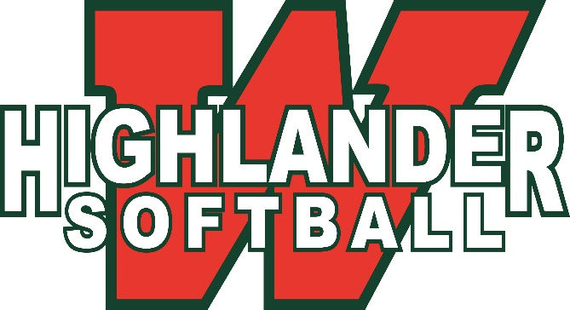
2019 Holiday

Home Run Derby

Benefitting CASA

Christmas Toy Drive

Waiver

Name: _____________________________ Activity: Holiday Home Run Derby

In order for your child to be able to participate in the activities, it is necessary for you to sign this statement indicating your understanding that the district does not carry insurance covering injuries your child may sustain. The undersigned are the parent or legal guardian of _____________________________________. By my signature, I am informing Conroe Independent School District that I understand that the district is not responsible for any accident or payments resulting from such accident.

In the event of injury to our child, we recognize that the Conroe Independent School District, its Board of Trustees, its agents and its employees are in no way liable for any injuries, medical expenses or damages and will have no insurance program. We acknowledge that we have made a choice on behalf of our child without any interference from anyone serving or employed by Conroe Independent School District in any capacity.

This _______ Day of _______, 20_____

Parent/Guardian Signature: ______________________________________________________

